Proposal to Accountable Africa Capital: Mine-to-Mill Monitoring for the Assosa CIL Plant
Sep 27, 2026 · @SVondee
Submitted by Smart Innovations GH to Accountable Africa Capital (AAC). Confidential.

1. Executive summary
Smart Innovations GH proposes a single Mine-to-Mill monitoring platform for AAC's privately owned CIL plant near Assosa, Benishangul-Gumuz, Ethiopia. It gives AAC verified, near real-time control of the four things that decide whether the plant is fed as planned:
- Excavator Watch: every excavator AAC lends to a concession holder is tracked and geofenced to that holder's licensed area.
- Fuel Intelligence: every litre of diesel is measured from tank to engine and matched to work done.
- Tailings Twin: drone surveys every two weeks, calibrated to a geologist baseline, measure the tonnes and estimated gold in each concession's tailings.
- Haul Trace: every dump truck trip between the plant and the concessions is GPS-tracked, sealed and weighed on arrival.
Together these produce a daily mass balance: tonnes measured on site, loaded, hauled and received at the plant weighbridge. Any gap shows up within hours.
Commercial offer. We propose a fixed-price pilot on 2 concessions for $372,000, running from November 2026 to February 2027. The pilot fee is credited against the full rollout. After the pilot, AAC chooses one of three pricing options for rolling out to all concessions (base case 8):
- Option A: fixed price plus an annual managed service.
- Option B: a monthly subscription, where Smart Innovations GH funds the hardware.
- Option C: delivery at cost plus a 20% share of verified savings.
Return to AAC. In the base case the platform delivers about $850,000 a year in benefits. Most of that is gold from tailings that would otherwise be lost between concession and plant. The rest comes from fuel, excavator use and haulage. Over five years, AAC's net present value ranges from $0.70M (Option C) to $0.96M (Option B), with payback in Year 1 or 2.
All prices are indicative and in USD, pending vendor quotes and AAC's operating data. They are valid for 60 days.

2. Our understanding of AAC's situation
AAC owns and funds a carbon-in-leach (CIL) plant near Assosa that processes tailings (ore waste) sourced from 4 to 10 partner concessions. To secure that feed, AAC lends excavators to concession holders and pays for fuel and haulage. AAC carries the asset, fuel and feed risk, but has limited real-time sight of what happens on each concession.
Operating context in and around Assosa that shapes this proposal:
- Licensing. Concession holders hold small-scale or artisanal mining licences issued through Ethiopia's Ministry of Mines and the Benishangul-Gumuz regional mining authority. AAC needs evidence that the excavators it has lent work only inside those licensed boundaries.
- Seasons. The main rainy season (kiremt) runs roughly June to September. It slows haulage, limits drone flying and changes tailings stockpiles. Our plan puts all installation and the pilot in the October to May dry season.
- Connectivity. Mobile coverage from Ethio Telecom and Safaricom Ethiopia is patchy away from Assosa town. Remote pits need store-and-forward devices and a satellite link through a provider licensed in Ethiopia.
- Security and access. Parts of Benishangul-Gumuz have had periods of insecurity. Field work needs security planning, local escorts where advised, and devices that keep recording when no one can reach the site.
- Imports and permits. Electronics and especially drones require import clearance, and drones need flight approval from the Ethiopian Civil Aviation Authority and the relevant security agencies. These are the longest lead items.
- Language and people. Field users work mainly in Amharic and local languages, so apps, alerts and training must be local-language first.
We will confirm each of these with AAC during mobilisation (Phase 0).

3. Objectives and success measures
We will judge success by five measurable outcomes, baselined in Phase 0 and confirmed at the end of the pilot.
AAC objective | Success measure | Target
Lent excavators work only on permitted ground | Operating hours outside a valid geofence | Zero unapproved hours; alert within 5 minutes
Every litre of fuel is accounted for | Unexplained fuel loss between tank and engine | Under 2% of fuel issued
Tailings stock is measured, not declared | Drone tonnage vs. tonnes received at the plant | Within about 5% per concession, bi-weekly
Every truck load reaches the plant | Loads traced from pit seal to weighbridge | 100% of loads
AAC gets feed and cost data it can bank on | Time to detect a discrepancy | Hours, down from weeks
The targets are proposals. AAC and Smart Innovations GH will agree the final pilot KPIs at Gate 1.

4. Solution overview
All four modules share one data backbone, so AAC runs one platform and one contract rather than four separate systems.
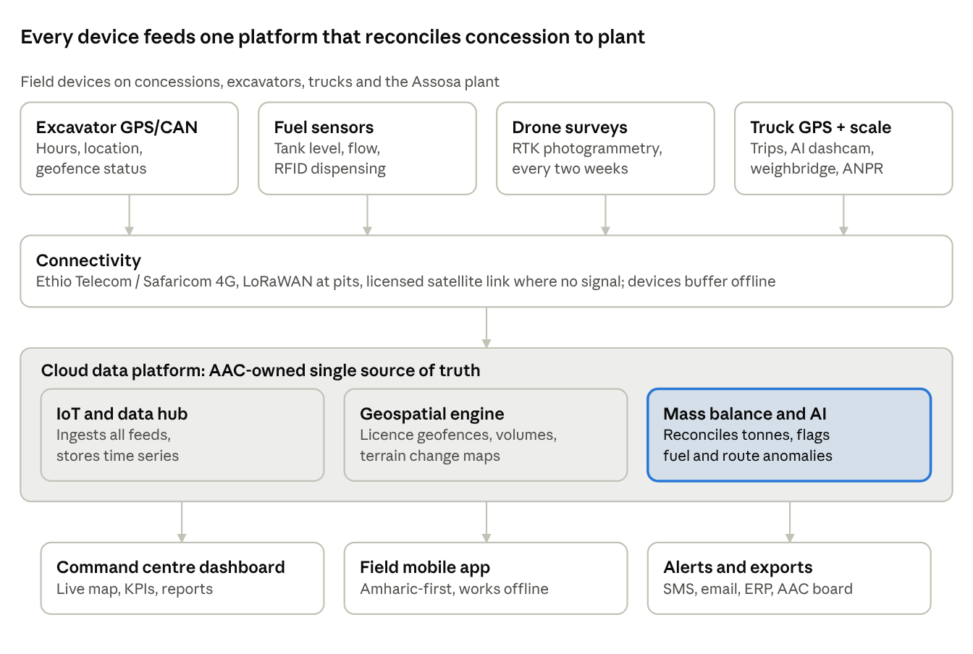
solution architecture · 4 field feeds, 1 platform, 3 outputs
Devices send data over whatever signal each site has and store it when there is none, so a pit that is offline for days loses no records. The platform joins every feed by concession, machine and time. That makes the cross-checks possible: fuel against engine hours, and truck tonnes against the fall in drone-measured stockpiles.
We use open standards where possible, including the ISO 15143-3 (AEMP 2.0) telematics interface, a PostGIS geospatial database, and standard drone survey formats. AAC is never locked in to one vendor, and AAC owns all data.

5. Module 1: Excavator Watch
Every excavator AAC lends carries a tamper-proof tracker. Each concession's licence boundary becomes a digital geofence, so AAC always knows where each machine is, whether it is working, and whether it is on licensed ground.
What we deliver
- Digital licence register. We load each concession's licence coordinates from the regional mining authority, check them with a GNSS survey of the boundary beacons, and link them to the licence number, holder and expiry date.
- Telematics. Where a machine supports it, we pull its manufacturer's telematics through the AEMP 2.0 interface. Older machines get a retrofit GPS/CAN tracker with a hidden backup battery and tamper alarm.
- Work-state detection. Engine hours, RPM and hydraulic or motion data classify each hour as digging, moving, idling or off.
- Alerts and controls. AAC and the concession supervisor get instant SMS and app alerts in Amharic and English for leaving the geofence, working out of hours, tracker power cuts and licences nearing expiry. An optional immobiliser can stop a machine starting outside its zone or schedule.
- Maintenance planning. Engine fault codes and hour meters drive service schedules and give early warning of failures, which matters when spare parts come through Addis Ababa.
Benefit to AAC | Business impact
Proof each machine works only on licensed ground | Protects AAC's licence standing and reputation, and its investor and ESG reporting
True utilisation per machine and concession | Idle machines moved to productive concessions; base case assumes a 10% uplift, worth about $134,000 a year
Deterrent to theft and misuse | Protects capital assets, each worth a large sum
Hours-based usage records | Fair, evidence-based cost recovery from concession holders
Planned maintenance | Less downtime at remote sites with long parts lead times

6. Module 2: Fuel Intelligence
Every litre is measured three times: leaving the bowser or tank, entering the machine, and burning in the engine. Any mismatch between the three is flagged automatically. This matters more in Ethiopia, where diesel supply can be tight and fuel carries a high resale value.
What we deliver
- Controlled dispensing. Smart dispensers with flow meters on each concession bowser and the plant tank release fuel only against an RFID tag on the machine and the operator's ID card. Each fill records litres, time and GPS position.
- In-tank sensors. A capacitive fuel-level sensor in each excavator tank detects every refuel and any sudden drop, such as siphoning.
- Engine burn data. CAN-bus fuel-rate data, or a flow meter on older engines, gives actual litres burned per engine hour.
- Efficiency KPIs. Litres per engine hour, litres per tonne of tailings moved, and idle-burn share, compared across machines and concessions.
- AI anomaly detection. The system learns each machine's normal burn and flags outliers: a fill with no rise in tank level, level drops with the engine off, or burn far above similar machines.
Benefit to AAC | Business impact
Every litre accounted for, tank to engine | Base case assumes a 12% cut in excavator fuel and 5% in truck fuel, about $116,000 a year
Idle-time visibility | Operator coaching and shutdown rules cut wasted burn
Litres-per-tonne KPI | Fuel spend tied directly to feed delivered to the plant
Audit-ready fuel records | Evidence for recovering fuel costs from concession holders, and for carbon reporting

7. Module 3: Tailings Twin
A survey drone flies each concession every two weeks and builds an accurate 3D model of its tailings, to within a few centimetres. Each model is compared with the previous one and calibrated to a geologist's baseline. The result is tonnes and estimated contained gold per concession, every two weeks, so AAC can see how each concession's tailings stock is changing.
The two-week cycle
- Baseline (once, then refreshed quarterly). A consulting geologist samples each concession's tailings with test pits or auger holes. The work measures bulk density and gold grade, with assays at an accredited laboratory. A first drone flight over fixed ground control points records the starting surface.
- Fly (every 14 days). An RTK drone flies a pre-set mission of about 1 to 2 hours per concession. It is operated by a pilot approved by the Ethiopian Civil Aviation Authority, or by a licensed Ethiopian drone service partner.
- Process (within 48 hours). Photogrammetry software produces an orthomosaic and surface model, accurate to about 2 to 5 cm with ground control.
- Measure. Stockpile volumes and a cut-and-fill map show material added, removed or moved since the last flight.
- Convert and reconcile. Volume becomes tonnes and estimated gold using the geologist's density and grade, and is checked against truck tonnes received at the plant.
\text{Tonnes} = \text{Volume (m}^3) \times \text{Bulk density (t/m}^3) \qquad \text{Contained Au (oz)} = \frac{\text{Tonnes} \times \text{Grade (g/t)}}{31.1035}
- Change detection. Image models flag new pits, encroachment beyond the licence boundary, ponding and unstable slopes.
- Rainy-season plan. From June to September we fly in weather windows and use free satellite imagery (Sentinel-2) to watch for major changes between flights.
- Grade learning. Plant assay results feed back into each concession's grade estimate over time.
Benefit to AAC | Business impact
Verified tonnage and grade per concession every two weeks | Plant feed plans and gold forecasts rest on measured stock, not declared stock
Depletion trend per concession | Early warning to secure new sources before feed runs short
Reconciliation with haulage | Tailings leaving a concession but not reaching the plant are exposed. This is the largest benefit, about $551,000 a year in the base case
Evidence-based payments | Concession holders are paid on measured tonnes and grade, so there are fewer disputes
Environmental and slope monitoring | Supports environmental compliance, rehabilitation planning and site safety

8. Module 4: Haul Trace
Every dump truck round trip becomes a digital, geotagged record: from the Assosa plant out to the concession, loading at the pit, and back to tipping at the plant. A load that stops off-route, arrives light or never arrives is flagged in real time.
What we deliver
- GPS trackers on every truck, reporting every 10 to 30 seconds and storing data when out of signal. Approved haul routes and stop zones are set as geofences.
- Digital waybill. At loading, the concession supervisor's app creates an e-waybill with a QR code or RFID seal. It records the truck, concession, time, GPS point and excavator. The app works offline and syncs when signal returns.
- Plant gate check. A number-plate recognition camera at the plant gate, linked to the weighbridge, matches each arriving truck to its waybill and records net tonnes.
- AI dashcams. Road-facing and driver-facing cameras record events and detect fatigue, phone use and speeding on regional roads.
- Trip analytics. Cycle time, queue time at pit and plant, trips per truck per day, and route deviations.
Benefit to AAC | Business impact
Unbroken chain of custody from pit to plant | Stops diversion of gold-bearing tailings
Weighbridge tonnes matched to loading records | Hauliers paid per verified tonne, not per claimed trip; about $30,000 a year in base-case savings
Cycle-time and queue analytics | Better dispatch, so more tonnes are delivered with the same fleet
Driver safety monitoring | Fewer incidents on community roads, and lower liability
Geotagged trip history | Evidence for regional authorities and communities on routes and timings

9. Command centre, reporting and data ownership
One dashboard shows every concession on a live map with the four modules layered on top. It runs on a wall screen at the plant and on the phones of AAC managers, including those outside Ethiopia.
- Live map: every excavator and truck, the licence geofences, and the latest drone image of each concession.
- Daily mass balance: tonnes measured on site, loaded, hauled and received at the weighbridge, with the gap at each step.
- Concession scorecard: tonnes delivered, grade, fuel per tonne, machine utilisation and open alerts, ranked across all concessions.
- Tailings report every two weeks: an automatic PDF per concession with volume change, tonnage, estimated gold and depletion forecast.
- Board and investor pack: a monthly summary of feed, fuel, utilisation and compliance for AAC's shareholders and lenders.
- Plain-language questions: managers can ask, for example, "Which concession had the highest fuel per tonne last month?" and get an answer drawn from the data.
Data ownership and protection
- AAC owns all data and holds the cloud account in its own name. Smart Innovations GH operates it under contract.
- Access is role-based for AAC, concession holders (their own data only), geologists and auditors.
- Data is encrypted in transit and at rest, with a full audit trail of every edit.
- Driver camera data is handled in line with Ethiopia's personal data protection law, including driver consent and retention limits. Local counsel will confirm the requirements in Phase 0.

10. Delivering in Ethiopia
Smart Innovations GH leads the programme and builds the platform. An Ethiopian partner and local staff deliver in the field. Our plan and pricing include the local costs and risks of working in Benishangul-Gumuz.
Topic | How we handle it
Local partner | An Addis Ababa-based technology partner provides a project coordinator, Amharic translation, customs support and a pool of field technicians. Named at contract signature.
Local team | Field technicians and the support engineer are Ethiopian, based in or near Assosa, and trained by our architects. This keeps response times short and builds local skills.
Imports | Hardware ships consolidated through Djibouti to Addis Ababa, cleared by a licensed agent. Orders are placed in week 1, with 6 to 8 weeks allowed for clearance.
Drone approval | We apply to the Ethiopian Civil Aviation Authority and the relevant security agencies in week 1. If approval is delayed, a licensed Ethiopian drone survey firm flies under subcontract, so the tailings baseline is not held up.
Connectivity | Ethio Telecom or Safaricom Ethiopia SIMs where there is coverage, LoRaWAN gateways at pits, and a satellite link through a licensed provider where there is none. Every device stores data when offline.
Security | A security plan is agreed with AAC before any field work: movement approvals, local escorts where advised, and no night travel. Security escort cost is included in the price.
Language | Mobile app, alerts and training materials in Amharic and English. Local-language support for drivers and operators through the partner.
Calendar | The plan allows for Genna (7 January) and Timket (19 January). All installation and the pilot run in the dry season, before the June to September rains.
Currency | Prices are in USD. Local costs paid in Ethiopian birr are converted at the prevailing National Bank of Ethiopia rate.

11. Implementation plan
If the contract is signed by 30 October 2026, the pilot goes live on 7 December 2026, AAC decides at Gate 2 on 5 March 2027, and all concessions are live by 28 May 2027. That is before the rains.
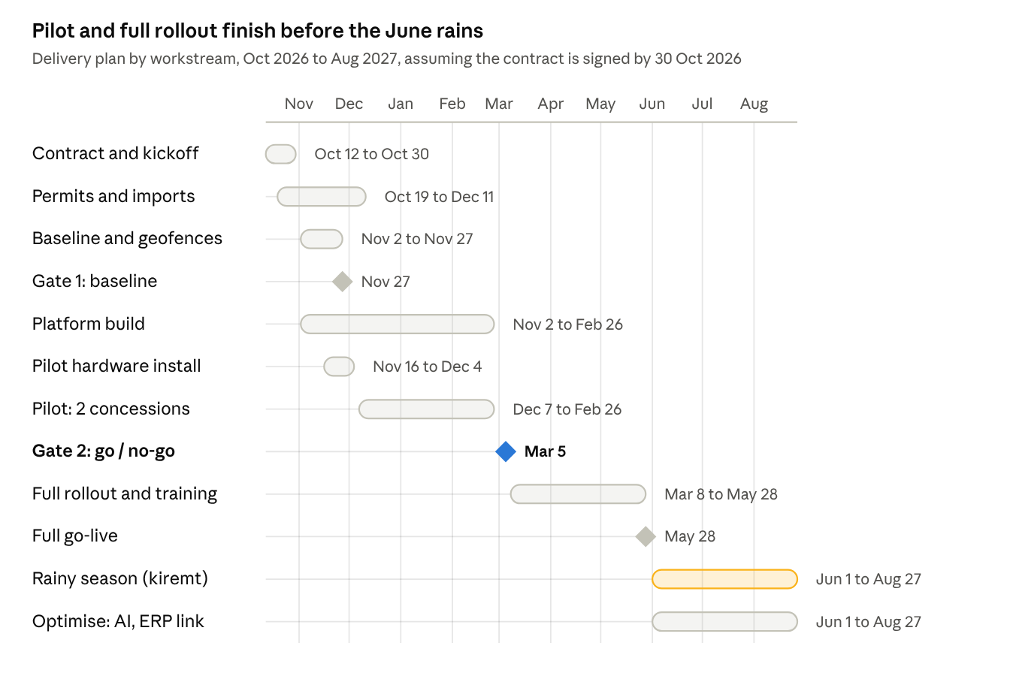
implementation timeline · 12 workstreams and milestones, Oct 2026 to Aug 2027
Phase | Dates | Main activities | Exit gate
Pre-start | 12 to 30 Oct 2026 | Contract, security plan, order hardware, file drone and import permits | Contract signed
0. Mobilise | 2 to 27 Nov 2026 | Collect AAC data, survey licence boundaries, geologist sampling, baseline flights, detailed design | Gate 1: geologist signs off baseline; AAC approves design and KPIs
1. Pilot | 16 Nov 2026 to 26 Feb 2027 | Install on 2 concessions, launch dashboard and app, run 6 drone cycles, train users, tune alerts | Gate 2: pilot KPIs met; AAC chooses a pricing option
2. Rollout | 8 Mar to 28 May 2027 | Fit remaining concessions, baselines, training, support desk | Full fleet reporting daily for 2 weeks; AAC sign-off
3. Optimise | From 1 Jun 2027 | AI models on full data, ERP link for payments, immobilisers, rainy-season flight plan | Quarterly review against KPIs
The pilot runs through Genna and Timket, when activity dips for a few days. At 12 weeks it still captures at least 5 normal two-week drone cycles. Each week of delay in signing moves every date by a week, and a delay of more than about 6 weeks would push the rollout into the rains.

12. Team and responsibilities
Smart Innovations GH is prime contractor and single point of accountability. AAC's input is focused on decisions, data and access.
Smart Innovations GH and partners
Role | Provided by | Responsibility
Programme manager | Smart Innovations GH | Plan, budget, risks, vendors, reporting to AAC
Solution architect / IoT lead | Smart Innovations GH | Architecture, device selection, integrations, security
Software team: 2 developers, 1 GIS/data engineer | Smart Innovations GH | Platform, dashboard, Amharic/English mobile app, mass balance
Data scientist | Smart Innovations GH | Fuel anomaly models, drone change detection, forecasts
Project coordinator and translator | Ethiopian partner | Local logistics, customs, permits, translation, community liaison
Field technicians (3) and support engineer | Ethiopian partner staff, Assosa-based | Installation, maintenance, first-line support
Consulting geologist | Independent, Ethiopia-registered | Baseline sampling, density and grade; signs off Gate 1
Licensed surveyor | Ethiopian partner | GNSS survey of licence beacons and ground control points
Drone pilots | Approved pilots or licensed Ethiopian drone firm | Flights every two weeks and data upload
Local counsel | Ethiopian law firm | Permits, contract clauses, data protection
What AAC provides
AAC role or input | Needed by
Executive sponsor to chair Gate 1 and Gate 2 (about 2 hours a month) | Contract signature
Project owner at the plant (about 20% of their time) | Contract signature
Licence coordinates, numbers and expiry dates for every concession | End of Phase 0, week 1
Register of lent excavators and trucks (make, model, serial, plate) | End of Phase 0, week 1
3 to 6 months of fuel issues, weighbridge records and feed receipts | End of Phase 0, week 2
Any existing geology or assay reports | End of Phase 0, week 2
Site access and introductions to concession holders and hauliers | Phase 0
Monitoring and data-sharing clauses in excavator lending and haulage agreements (we provide draft wording) | Before pilot install
Weighbridge access and power and network at the plant gate | Before pilot install
Rugged phones and command centre, if AAC buys them directly | Before pilot go-live

13. Commercial proposal
AAC commits only to a fixed-price pilot. At Gate 2, with pilot results in hand, AAC chooses how to pay for the full rollout. All prices are in USD and exclude Ethiopian VAT and withholding tax. Rollout prices assume 8 concessions, 16 lent excavators and 24 trucks, and are adjusted pro rata to the confirmed fleet.

Step 1: Fixed-price pilot, $372,000
The pilot covers Phase 0 and Phase 1 on 2 concessions:
- hardware for 4 excavators, 6 trucks and 3 fuel points, plus 1 gateway, 1 drone kit, the plant ANPR and weighbridge link, and the command centre, landed in Assosa and installed
- the platform, dashboard and Amharic/English app
- geologist baselines and surveys for both concessions
- three months of operation, with 6 drone cycles
Pilot milestone | Share | Amount
Contract signature | 40% | $148,800
Gate 1: baseline signed off | 30% | $111,600
Pilot live on 2 concessions | 20% | $74,400
Pilot results report delivered | 10% | $37,200
The hardware stays at the plant whatever AAC decides. If AAC proceeds, the full pilot fee is credited against the rollout under any option.

Step 2: Rollout, three options
Option A: Fixed price plus managed service. AAC owns all hardware.
- Implementation fee: $709,000 in total, including the $372,000 pilot. The balance of $337,000 is paid 50% at Gate 2 and 50% at full go-live.
- Managed service during the rollout (March to May 2027): $90,000.
- Managed service from full go-live: $30,000 a month. This covers support, all drone surveys, geologist refresh, cloud, connectivity, maintenance and device replacement.
Option B: Monitoring-as-a-Service subscription. Smart Innovations GH funds, owns and replaces the hardware.
- Onboarding fee: $85,000, covered by the pilot fee. The remaining $287,000 of the pilot fee is credited against the first subscription invoices.
- Monthly subscription: $240 per excavator, $120 per truck, $4,000 per concession, and $3,000 for the plant hub. At 8 concessions this totals $41,720 a month.
- Five-year term, with a minimum of 6 concessions or $32,000 a month.
Option C: Gain-share. AAC owns the hardware; we share the upside and the risk.
- Implementation at cost: $567,000 in total, including the pilot. The balance of $195,000 is paid 50% at Gate 2 and 50% at go-live.
- Managed service: $72,700 during the rollout, then $24,250 a month.
- Gain share: 20% of verified savings, paid quarterly. Verified savings are fuel saved, AAC's margin on extra gold from stopped leakage, and haulage over-claims removed, all measured against the Phase 0 baseline. In the base case that is about $139,000 a year. A cap can be agreed.
For AAC, base case | Option A | Option B | Option C
Cash needed in Year 0 (to full go-live) | $799k | $372k | $654k
Fees in a full year of operation | $360k | $501k | about $430k, including gain share
Total fees over Year 0 to Year 5 | $2.60M | $2.64M | $2.81M
Who owns the hardware | AAC | Smart Innovations GH | AAC
Who carries performance risk | AAC | Shared | Mostly Smart Innovations GH

14. Business case for AAC
In the base case the platform returns about $852,000 a year to AAC. Every option pays back in Year 1 or 2. The figures cover Year 0 (implementation, November 2026 to May 2027) plus five operating years, discounted at 18% to reflect country risk.
Annual benefit (full year, 8 concessions) | USD | Basis
Margin on extra gold from stopped tailings leakage | 550,935 | 3% more feed secured on 400,000 t a year, at 1.2 g/t, 85% recovery, $3,500/oz and 40% AAC margin: about 394 oz
Excavator utilisation uplift | 134,400 | 10% more productive hours at $35/h
Fuel savings | 116,280 | 12% of excavator diesel and 5% of truck diesel, at about $0.85/L
Haulage over-claims removed | 30,000 | 3% of haulage cost at $2.50/t
Theft and insurance cost avoided | 20,000 | $1,250 per excavator
Total | 851,615

Return to AAC, base case | Option A | Option B | Option C
Net present value, after all fees and AAC's own costs | $0.77M | $0.96M | $0.70M
Payback | Year 2 | Year 1 | Year 2
Sensitivity. AAC's return depends most on how much tailings leakage the platform stops, then on the number of concessions, grade and gold price. Fuel, hardware and running-cost assumptions matter much less. Each row below moves one driver from low to high while the others stay at base. Figures are AAC NPV in $k.
Driver (low to high) | Option A | Option B | Option C
Extra feed secured, 1% to 5% | -411 to 1,959 | -187 to 2,183 | -249 to 1,648
Concessions, 4 to 10 | -54 to 1,217 | 395 to 1,302 | -10 to 1,078
Tailings grade, 0.8 to 1.6 g/t | 181 to 1,367 | 405 to 1,591 | 225 to 1,174
Gold price, $2,800 to $4,200/oz | 418 to 1,130 | 642 to 1,354 | 415 to 984
Running cost, 0.85x to 1.25x | 956 to 470 | 998 to 998 | 847 to 454
Excavator fuel saving, 6% to 18% | 616 to 932 | 840 to 1,156 | 573 to 826
Discount rate, 14% to 24% | 921 to 591 | 1,102 to 869 | 825 to 543
Hardware cost, 0.8x to 1.3x | 845 to 668 | 1,004 to 989 | 756 to 615

Scenario, AAC NPV $k | Option A | Option B | Option C
Bear: 5 concessions, costs +15 to 20%, gold $3,000, 1.5% feed secured, 1.0 g/t | -877 | -250 | -661
Base | 774 | 998 | 700
Bull: 10 concessions, gold $4,000, 4% feed secured, 1.4 g/t | 3,562 | 3,468 | 2,962
Option B figures in these two tables exclude the pilot-credit timing, which lowers them by about $36k.
What this means for AAC
- The platform breaks even for AAC once it secures about 1.7% more feed than today under Option A. The pilot is designed to measure exactly this before AAC commits to the rollout.
- Option B protects AAC best when volumes are uncertain: it stays positive even at 4 concessions, because Smart Innovations GH carries the hardware.
- Option C lowers AAC's fixed fees and ties our earnings to verified results. It suits AAC if the pilot confirms strong savings.
- With fewer than 5 concessions, or if the pilot finds little leakage, AAC should expect a thin return. The Gate 2 decision guards against that.

15. Risks and mitigations
Risk | Likelihood | Mitigation
Drone import or flight approval delayed | Medium | Apply in week 1; fall back to a licensed Ethiopian drone survey firm; ground GNSS survey for the baseline if needed
Hardware held at customs | Medium | Licensed clearing agent; consolidated shipment; 6 to 8 weeks built into the plan; small spares stock held in Addis Ababa
Security incidents limit site access | Medium | Agreed security plan, local escorts, no night travel; devices keep recording and sync later; remote support from the command centre
No mobile signal at remote pits | High | Store-and-forward devices, LoRaWAN gateways and licensed satellite links
Tracker tampering or removal | Medium | Hidden installation, backup batteries, tamper and power-cut alerts, optional immobiliser
Resistance from concession holders or drivers | Medium | Monitoring clauses in lending and haulage agreements; concession holders see their own scorecards; local-language training
Poor baseline data skews tonnage | Low to medium | Independent geologist sign-off at Gate 1; recalibration against plant assays
Rainy season disrupts flights and haulage | High, June to September | All installs and the pilot in the dry season; flights in weather windows; satellite imagery between flights
Foreign exchange and price changes | Medium | USD pricing; hardware prices fixed once vendor quotes are accepted
Lower than expected leakage | Medium | Pilot measures it before rollout; Gate 2 lets AAC stop or re-scope

16. Assumptions, exclusions and validity
Key assumptions (to confirm with AAC in Phase 0)
- 8 concessions at full rollout, each with 2 lent excavators, 3 dump trucks and 1 fuel point, plus a fuel point at the plant.
- Tailings feed of about 50,000 t a year per concession, at a head grade of about 1.2 g/t and CIL recovery of about 85%.
- The platform secures about 3% more feed by stopping leakage. The pilot will measure the real figure.
- Gold at about $3,500/oz and diesel at about $0.85/L. Both are approximate and should be updated to current prices.
- An existing, working weighbridge at the plant, with power and network at the gate.
- Hardware prices are approximate market estimates, and import costs are taken as 35% of hardware value. Both will be fixed once vendor and clearing-agent quotes are accepted.
Exclusions
- Ethiopian VAT (15%), withholding tax and any other statutory levies.
- Civil works, weighbridge purchase or repair, and plant power or network upgrades.
- The cost of armed security, if required beyond local escorts.
- LiDAR drone payloads (about $20,000 extra per kit), unless vegetation makes them necessary.
- Changes to scope beyond 10 concessions or the fleet sizes above, which are priced pro rata.
Validity. This proposal is valid for 60 days from its date. Prices are indicative until vendor quotes are confirmed in Phase 0. Any change above 10% will be agreed with AAC before it is applied.

17. Next steps and acceptance
To keep the pilot and rollout inside the dry season, we propose:
- ☐ AAC review and questions on this proposal, with a call to walk through it, by Oct 16, 2026
- ☐ AAC shares its fleet register, licence coordinates, and recent fuel and weighbridge records, so we can firm up prices
- ☐ Choose the 2 pilot concessions, and agree the security plan for field work
- ☐ Sign the pilot contract by Oct 30, 2026
- ☐ Kickoff in Assosa on Nov 2, 2026
Acceptance
 | For Accountable Africa Capital | For Smart Innovations GH
Name
Title
Signature
Date
The proposal expires on Nov 26, 2026, 60 days after this proposal's date.

